PHISHING EMAIL DETECTION MODEL

Introduction
Phishing attacks are among the most common cyber threats. Attackers send fraudulent emails to trick users into revealing sensitive information such as passwords, banking credentials, and personal details.
This project develops a machine learning model that automatically classifies emails as Phishing or Safe using textual analysis.

Objectives
- Detect phishing emails automatically.
- Extract useful text features.
- Train a machine learning model.
- Evaluate model performance.
- Predict unknown emails.

Technologies Used
- Python
- Pandas
- Scikit-Learn
- TF-IDF Vectorizer
- Naive Bayes Classifier

Methodology
- Collect email dataset.
- Preprocess email text.
- Convert text into TF-IDF vectors.
- Train classifier.
- Evaluate using accuracy and confusion matrix.
- Predict new emails.

Features
- Email classification
- Accuracy calculation
- Confusion matrix
- Classification report
- Real-time prediction

Results
The model successfully classifies emails as Phishing or Safe based on textual content and suspicious keywords.
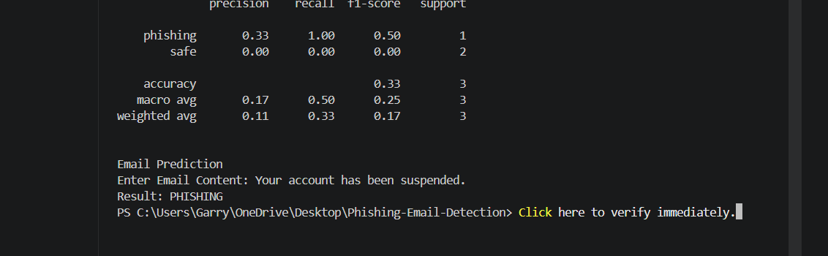

Applications
- Email Security
- Spam Filtering
- Cybersecurity Systems
- Fraud Detection

Future Enhancements
- Larger datasets
- Deep learning models
- URL analysis
- Attachment scanning
- Web-based interface

Conclusion
The Phishing Email Detection Model demonstrates how machine learning can be used to identify phishing attempts. The system helps improve email security by automatically detecting suspicious messages and reducing cyber threats.

